Order Inquiry
The Order Inquiry returns info based on the details sent.
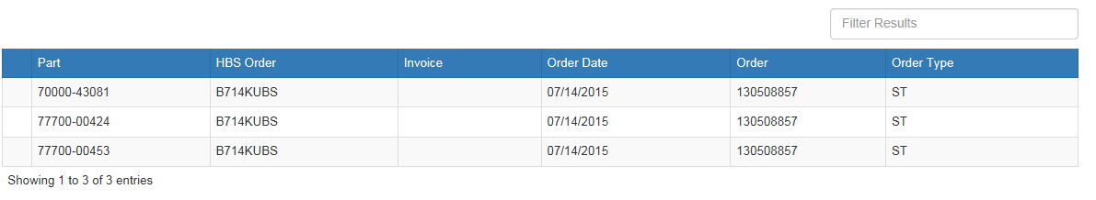
In addition, you can click on any given line and get detailed info for that particular part number.
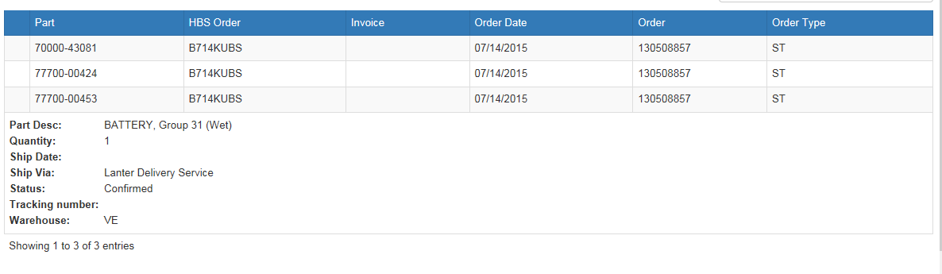
Dealer Inventory Inquiry
From the Inquiry screen you can also do a Dealer Inventory search.

- Enter a Kubota part number.
- The search will show:
  - The dealers who have that part number
  - The quantity they have on hand
  - Their contact info

